**Learning Management System – Faculty Module**

**Login**

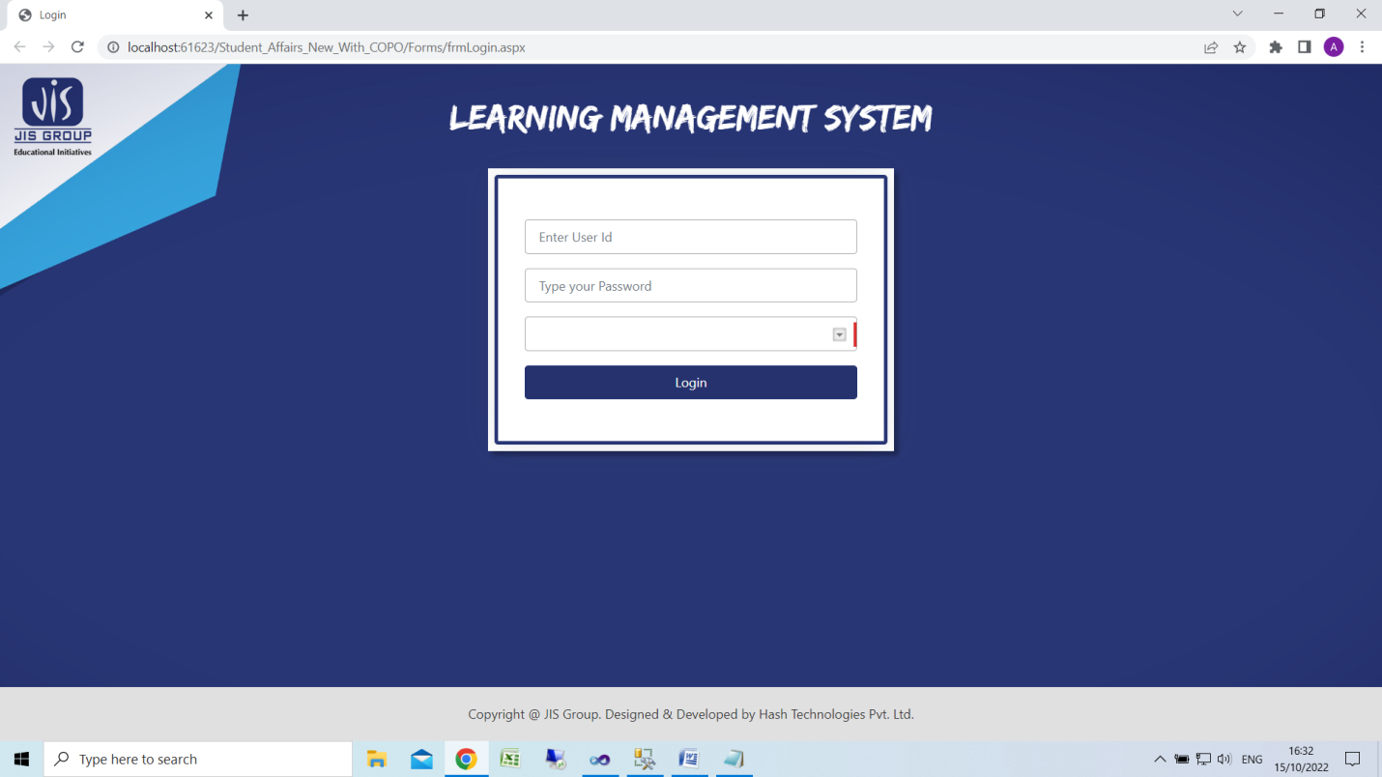

**Home Screen**

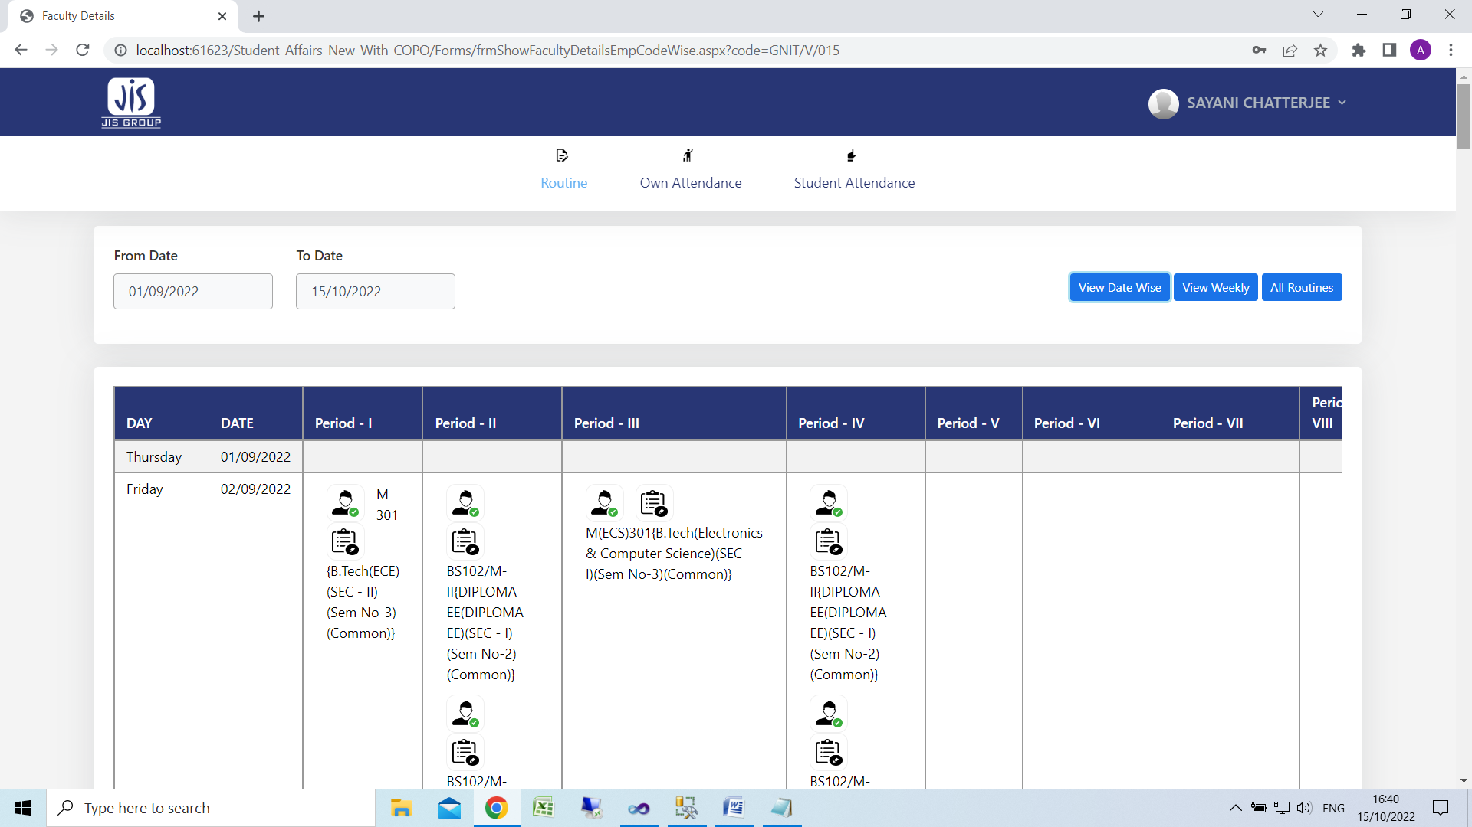

1. Click here for class attendance
2. Click here for lesson plan preparation
3. Click here to view weekly routine
4. Click here to view own attendance

**Class Attendance**

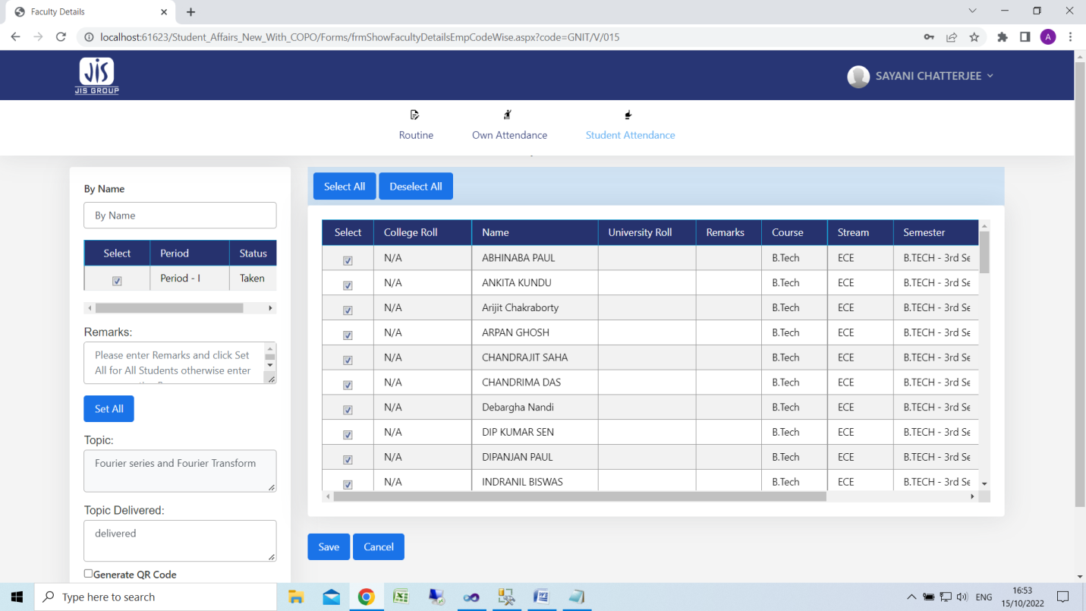

1. Click select all if all students are present or you check/uncheck check box
2. Enter topic delivered details & click Save button

**Lesson Plan**

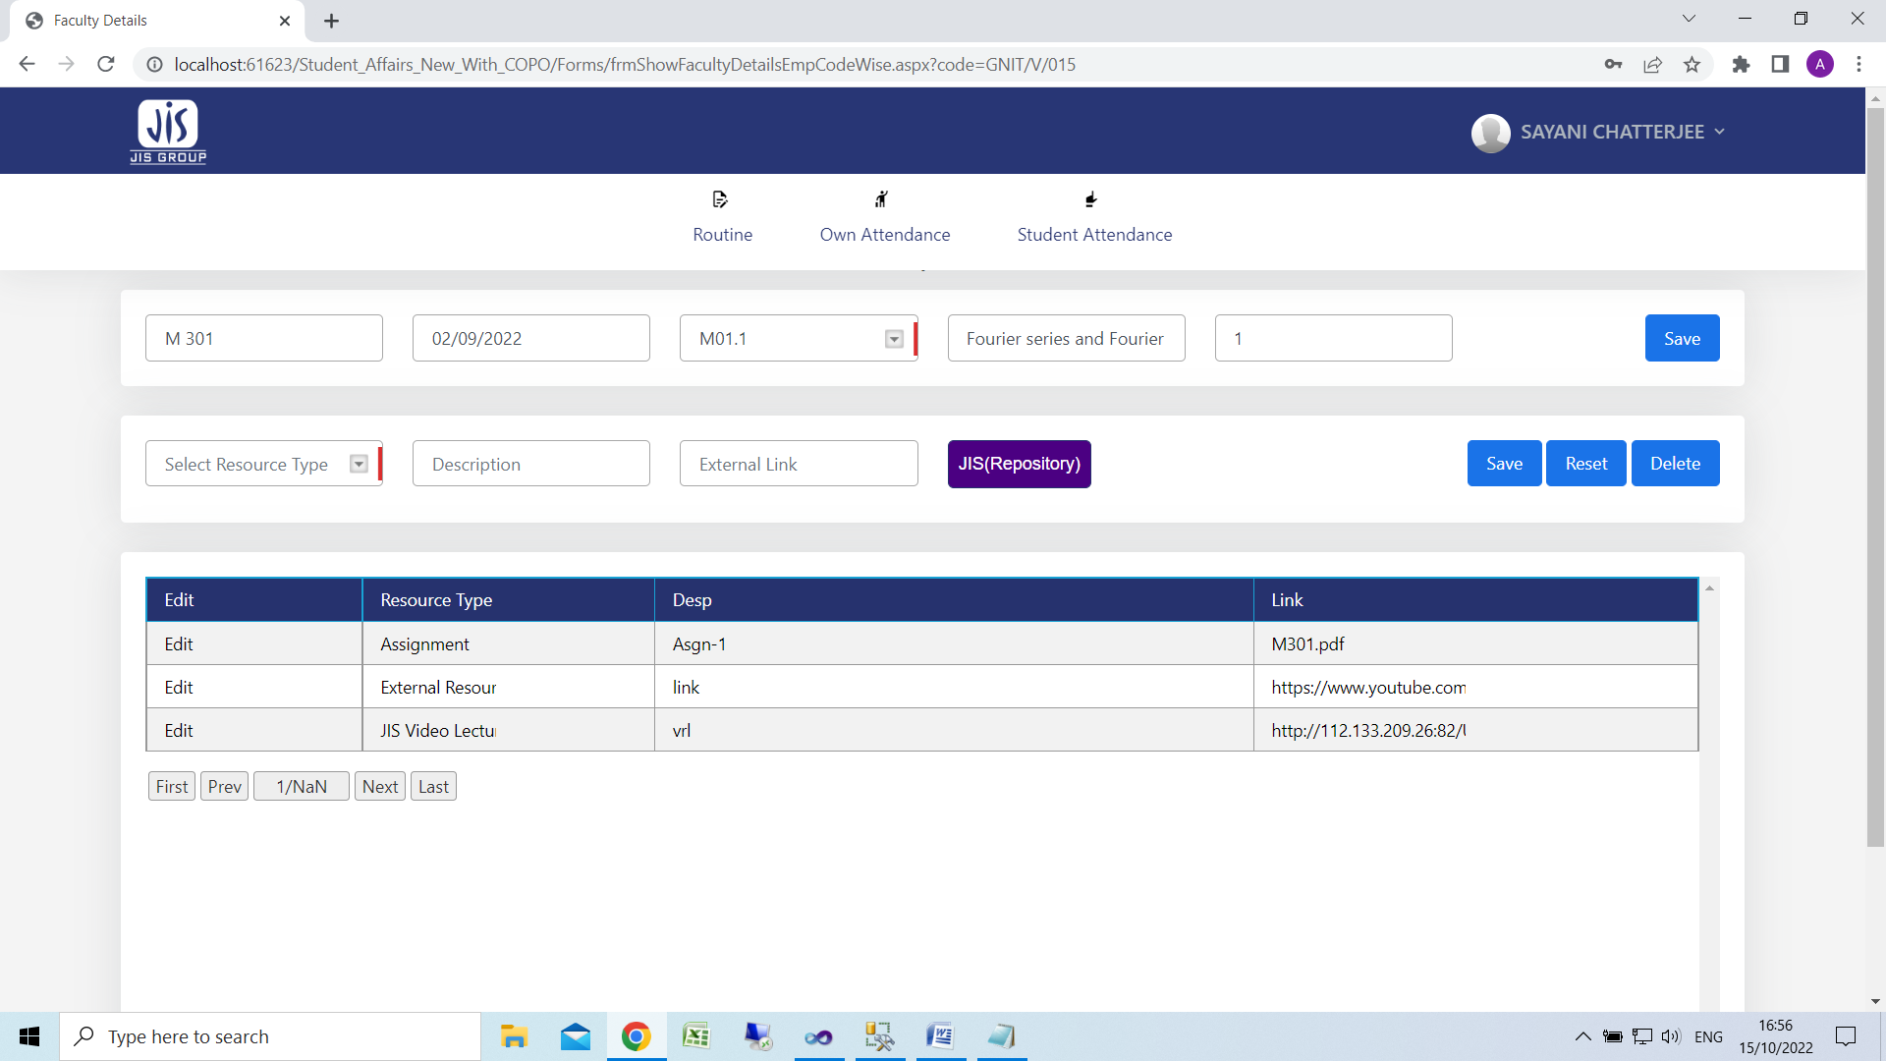

Module wise Lecture mapping

1. Select Module & Sub Module
2. Enter Lecture number
3. Click save

Class Note / Resource material

1. Select resource type
2. Enter description
3. Upload file for Assignment/Class note/Class lecture
4. In case of external resource link & JIS(Repository) type link on external link text box.
5. Click save

**View weekly Routine**

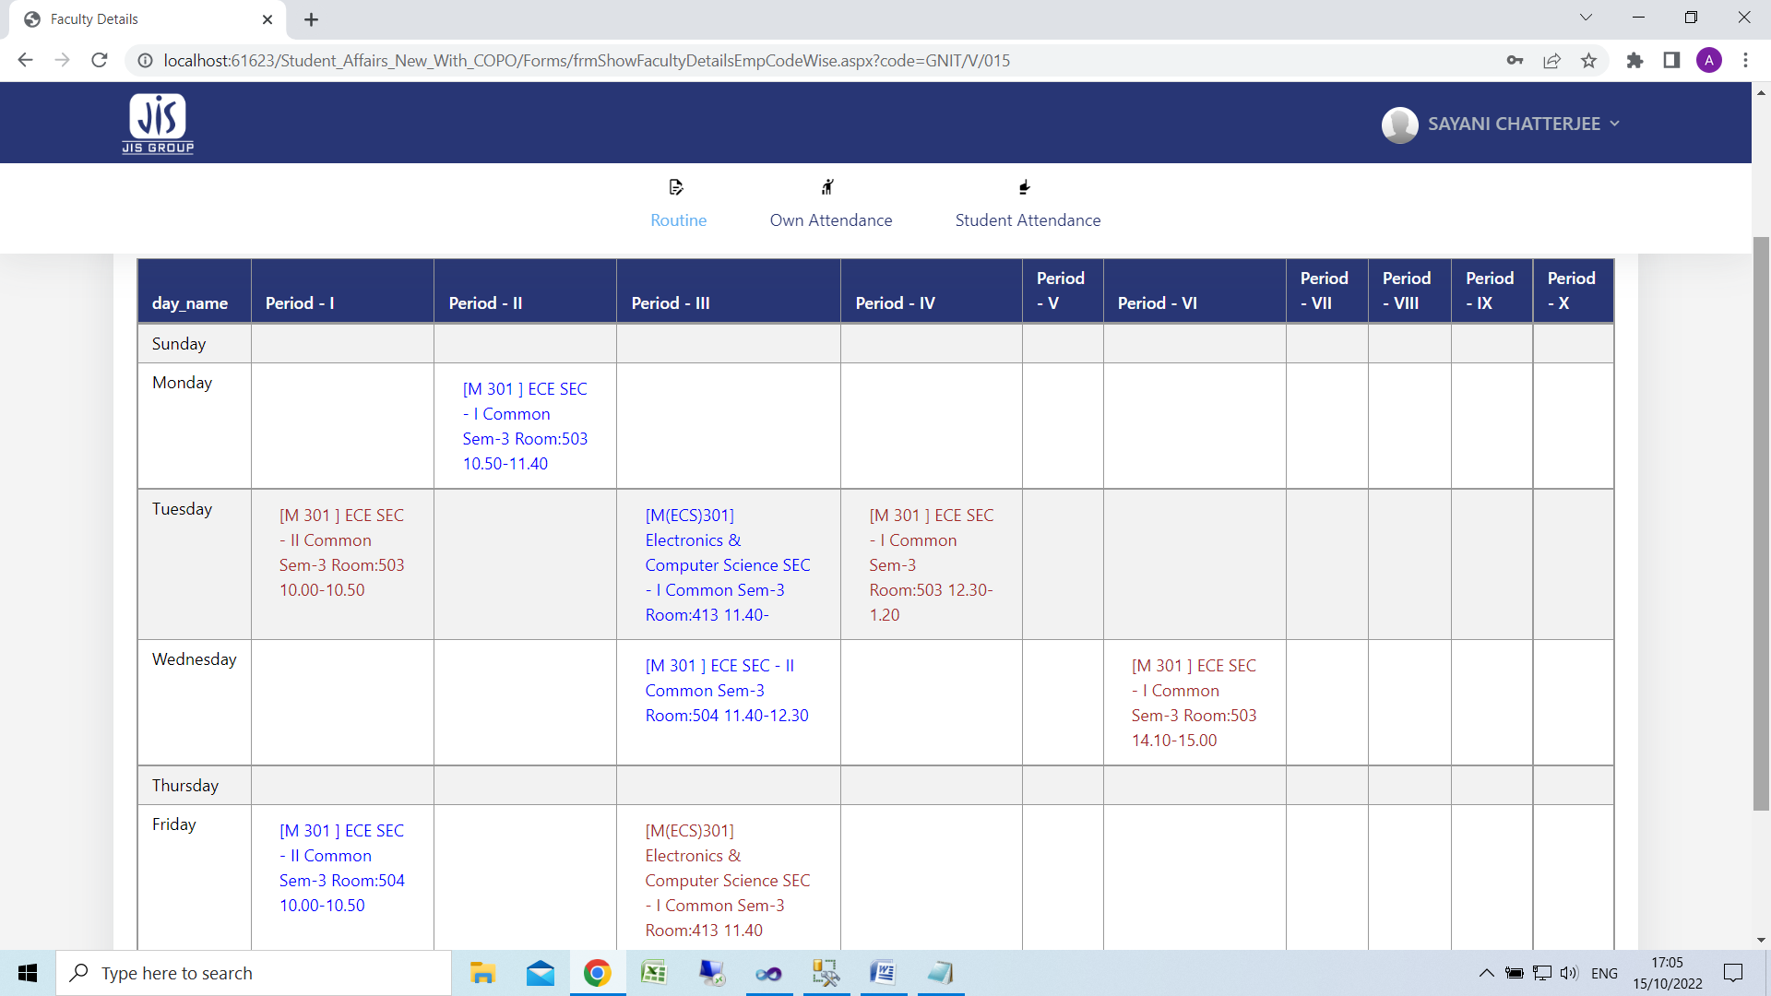

**Own Attendance Screen**

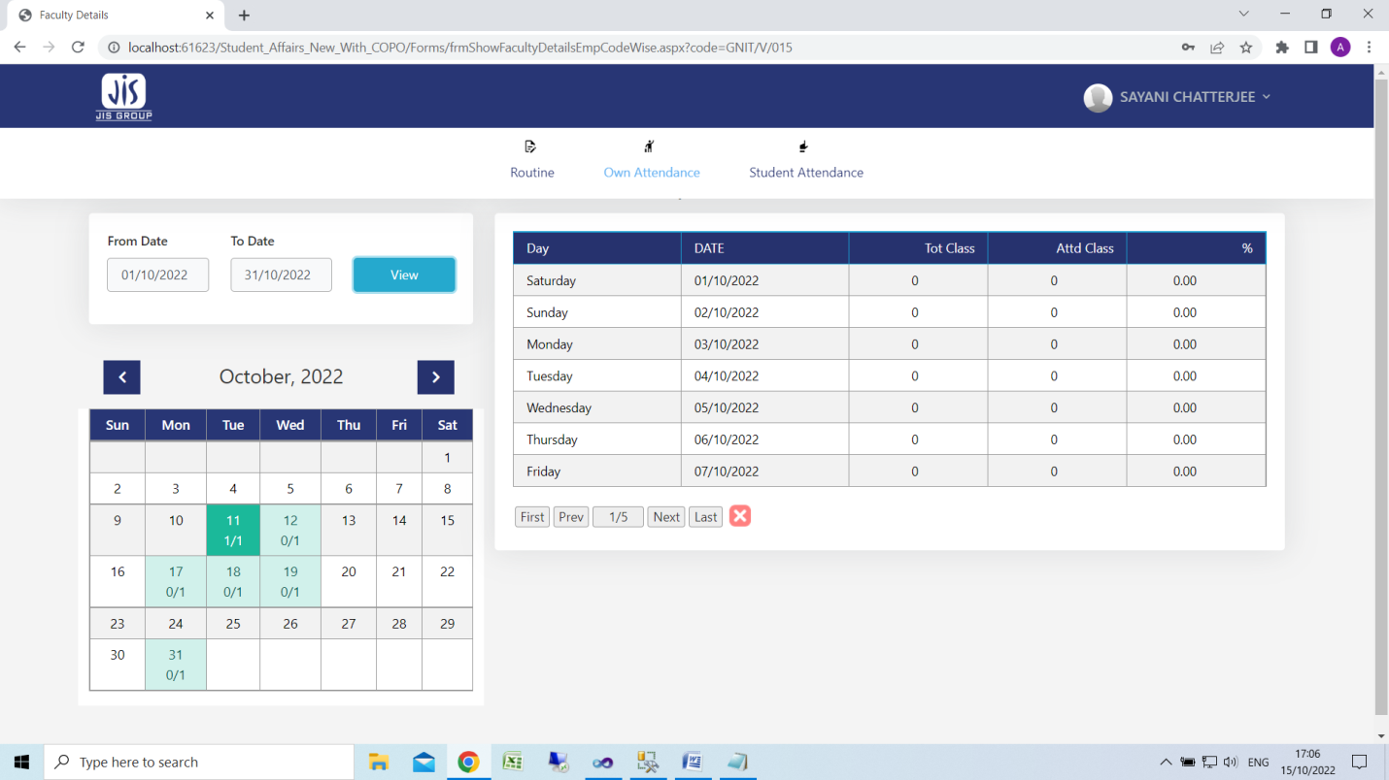

Click View to display own attendance